Digital Pages Changes

- Navigation – remove SkidIQ, but keep the page live
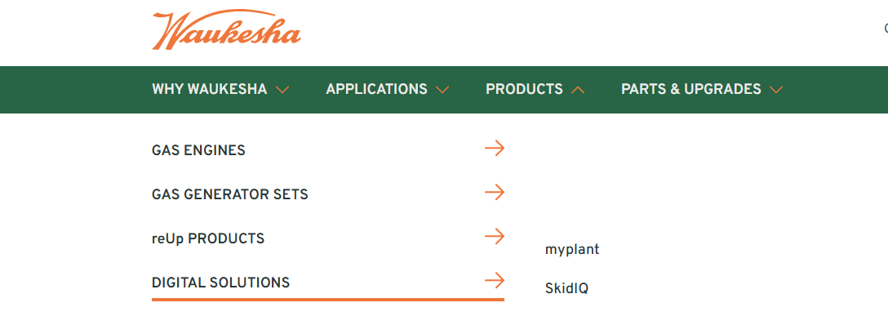
- Digital Solutions Page: Digital Solutions | INNIO Waukesha Engine

Digital Solutions
A smarter future
for our customers.
Today you want to improve uptime and gain bettervisibility into your operation. Waukesha, an INNIO Group brand, offers digital solutions designed to support more efficient and informed operations.
For decades, Waukesha products have supported innovation in the energy sector. Powered by advanced digital technologies and cloud-based solutions, we also offer a broad portfolio of digital monitoring products, including an engine monitoring system as well as skid analysis and control capabilities. With a strong focus on customer needs these technologies are designed to help improve performance while managing your operations remotely, wherever you are.
You fuel our Digital Solutions development
Thanks to our customers’ continuous feedback, our digital offerings keep evolving to deliver additional benefits.
- You asked for greater cost transparency, easier remote access, and enhancedenergy market solutions.
We’ve developed digital tools for our customers that combine our engine expertise and advanced data collection technology to help accelerate issue resolution.
- We listened to how important further improvements in reliability and efficiency are to you.
Our data scientists continuously develop new algorithms to collect information for condition-based maintenance, while offering integrated solutions designed to help improve efficiency across fleet installations.
- You voiced a desire to monitor your entire site in a single platform.
Our AI-driven myplant platform helps address this need, connecting assets beyond Waukesha engines. Ultimately, you can manage your assets remotely and in real time while supporting more efficient and timely equipment monitoring from a single platform.

Remove SkidIQ on the page

- SkidIQ page - SkidIQ | Digital Monitoring | INNIO Waukesha Engine
SkidIQ
INTEGRATED ENGINE
AND COMPRESSOR
MONITORING.

- The SkidIQ Gas Compression product suite, a cloud-based digital solution, is designed to help operators improve efficiency, support emissions reduction and reduce operating expenses.
- By combining Waukesha engine analytics with real-time compressor monitoring and optimization capabilities, SkidIQ providesan integrated platform for monitoring and managing the full skid package.
- SkidIQ enables operators to remotely monitor and analyze full compressor skids in real time through an integrated engine and compressor monitoring platform monitoring.
- Old case study at the bottom. Exchange it for this one – https://www.waukeshaengine.com/more-than-merely-monitoring/. The new case study does not include mention of Detechtion at all

key features
SkidIQ is a cloud-based platform for natural gas compressor operators and gas compression leasing companies, providing tools to monitor engine and compressor performance and identify potential issues, with features including:
Targeted Diagnostics
Engine diagnostics with direct access to the Waukesha e-help manual.
Real-Time Analytics
Integrated compressor and engine analytics to support real-time visibility into skid performance and support identification of potential improvement opportunities.
Advanced Functionality
Engine balance plots to highlight variation in power cylinder output across the engine and engine triaxial plots to show engine operating conditions over time.

Old Case study:
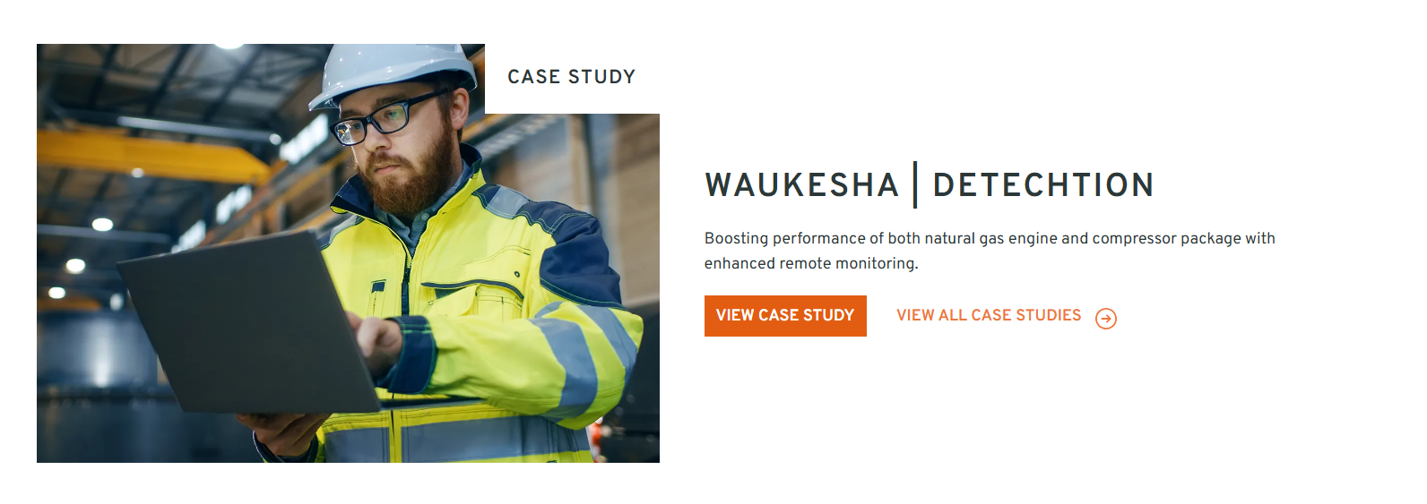
Exchange with this modified case study:
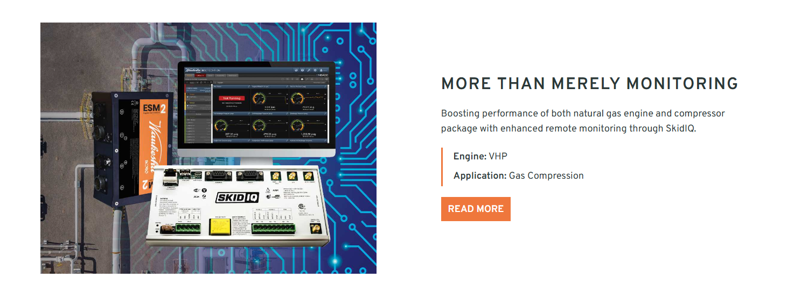
Background
SkidIQ supports expanded asset connectivity through a customer-centric digital ecosystem. An additional user benefit is the ability to identify potential opportunities to improve natural gas production throughput, which may support increased gas movement and revenue potential, depending on asset configuration and operating conditions.
Product Spotlight
As part of overall remote monitoring activity, both engine and compressor data were analyzed by the Remote Operations Center (ROC) and Engineering Account Managers (EAMs). Utilizing insights based on the current engine model, configuration, control system, asset age, and operating profile, the teams used various Conversion, Modification, and Upgrade (CMU) kits to model “what if” scenarios and assess potential production outcomes. This analysis helped estimate potential incremental production, indicative daily revenue impact, and possible payback or return-on-investment (ROI) periods for specific assets.
Results
Through the collaborative efforts of the ROC and EAM, throughput improvement opportunities were identified SkidIQ provides enhanced connectivity and visibility to support asset performance.
- Old case study - Enbase Detechtion | Case Study | INNIO Waukesha Engine

Discover digital ssolution for your project.
Learn more about Waukesha’s portfolio of digital products, solutions, and service options.

- Remove quote
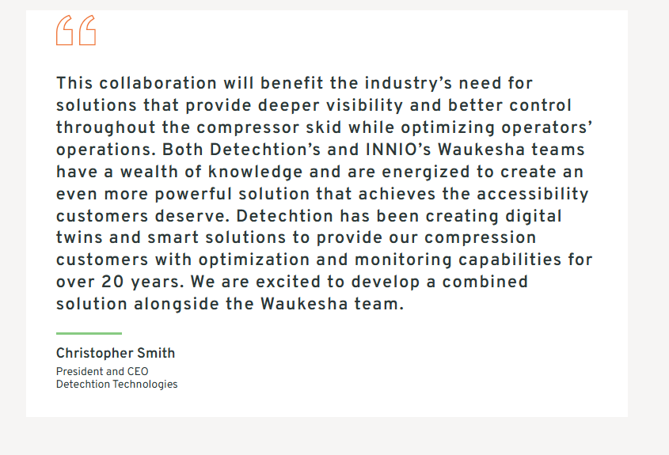
5. Remove this case study from the main case study page:
Case Studies | Engine Efficiency | INNIO Waukesha Engine - MORE THAN MERELY MONITORING | Case Study | INNIO Waukesha Engine
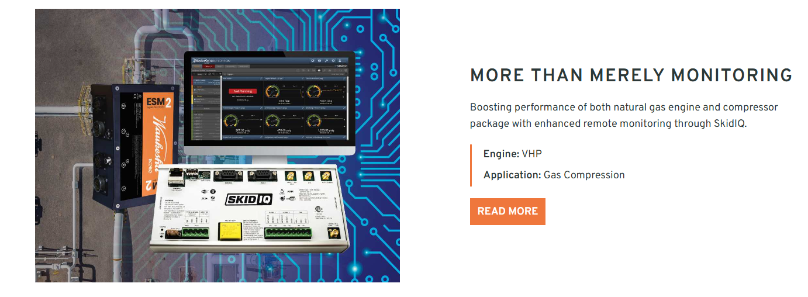

myplant FOR POWER GENERATION AND GAS COMPRESSION
INNIO Group’s myplant platform through its Asset Performance Management (APM) solution supports remote monitoring and asset management, as well as preventive and predictive analytics for your engines.
myplant | Digital Monitoring | INNIO Waukesha Engine
myplant
Helping you improve
fleet
uptime and
reliability.
myplant’s APM solution provides remote monitoring and preventive and predictive analytics for power generation and gas compression operations. This AI-enabled and cloud-based technology lets you manage your assets wherever you are – securely and in real time.
KEY BENEFITS
With the myplant’s APM sSolution bringing preventive and predictive analytics to your power-generation operations, users gain access to real-time monitoring and fleet-wide reporting to provide business intelligence insights. Currently, approximately 13,000 more than 12,000 active engines are connected to myplant remotely, using features designed to support operational decision-making:
- 24/7 remote monitoring and access to data
- Mobile app access and data exporting
- ESM and ESM 2 E-Help Manuals (mobile and desktop)
- Fleet reporting of key performance indicators and data items
- Waukesha manuals, bulletins and video training guides
- Coolant health reporting merged from several data sources to one platform
- Customized alerts and user-defined analytics
- Waukesha service tools such as Lifecycle Parts Lists

COMPATIBLE ENGINES
- All Waukesha units with ESM 2 Controller
- All packages with Spartan Remvue, Murphy Controllers, Allen-Bradley Controllers and Altronic Controllers
Standard hardware includes a cell router, magnet-mounted antenna and standard ethernet cables.

SECURITY APPROACH
Security is exceptionally important to us – because it’s so important to you. That’s why our myplant APM sSolution includes protective cybersecurity measures and processes designed to support the secure operation of your connected assets. .At all times, your data will be protected, access is tightly controlled through multiple security measures and only essential data is transferred. Data transmissions are encrypted, and supported by our cybersecurity experts.
Discover digital solutions for your project.
Learn more about Waukesha’s portfolio of digital products, solutions, and service options.

